CRYPTOGRAPHY AND NETWORK SECURITY

PROJECT PLAN

MEMBERS

1. 121715- Wayne Kipruto
2. 117919 Shem Bonga

DESCRIPTION

The final project will be a web based mobile application which will use triple DES algorithm. The website will be done using HTML and CSS for the frontend and PHP for backend functionality. The database we will use is MySQL.

Work division

1. Website Creation

Frontend: Shem

Backend: Wayne

1. Database creation – Both
2. Encryption and decryption of algorithms -Both
3. Writing final project report – Both

WORKFLOW

Deliverable 1- Website and database

Deliverable 2- Full functioning website with DES encryption

Deliverable 3- Final project report

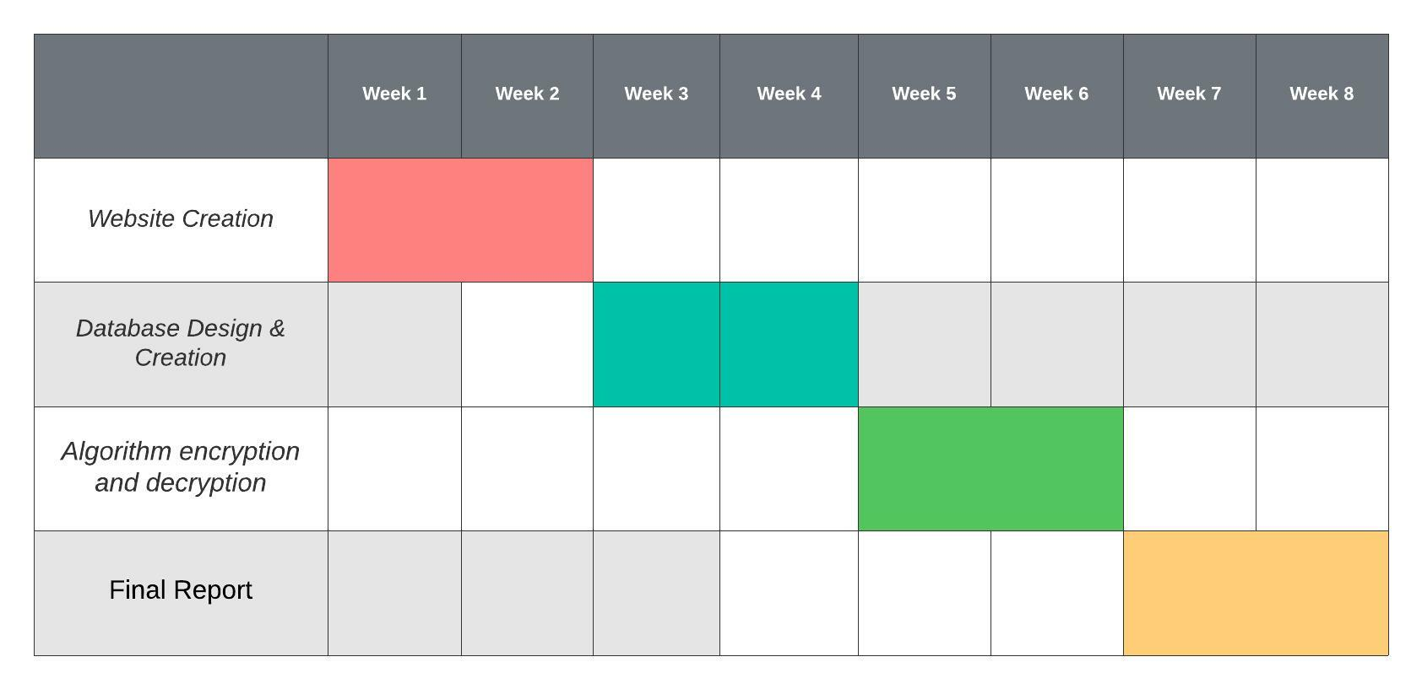

Figure :Gantt Chart